. Furthermore, collaboration edges exhibit more consistency (fewer times when the relationship changes in consecutive problem sets) than one would expect just given the number of times that they are present in the networks. This trend suggests these relationships mostly switch on and off rather than popping in and out of existence.

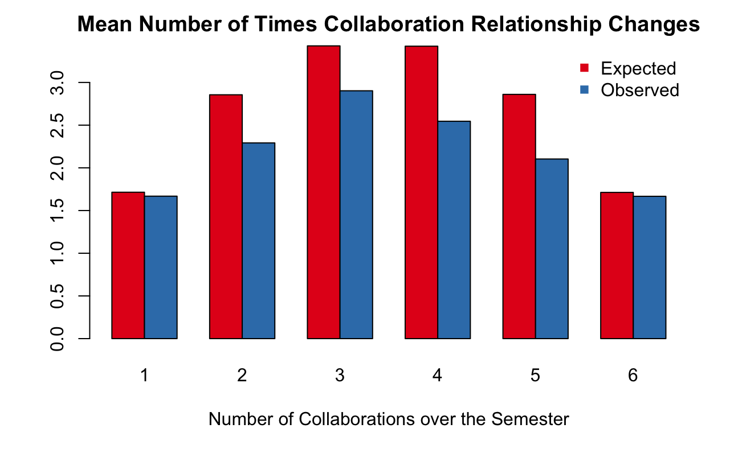

baseline homophily only corresponds the relative prevalence of different groups, while in-breeding homophily corresponds to the differential treatment of in-group and out-group members.

There is also evidence that more integrated social environments can lead to more women participating in STEM fields (Legewie and DiPrete 2014). This suggests that the segregated nature of the collaborative ties may be indicative of a larger trend at Yale that contributes to the imbalanced nature of STEM majors. Integrating men and women socially, and especially in classroom collaboration, could be an effective way to increase the number of women in these classes.

Another one of findings is that, related to similar findings that women are more generous in the dictator game (2003). This conclusion was drawn from the fact that women were more likely than men to choose team pay instead of individual pay when they were abler than his or her partner, raising the partner’s income at the expense of his or her income (Kuhn and Villeval 2003).

This small improvement is reflected in the small magnitude of the coefficients trained for this model.

. Another explanation is that women’s status as the underrepresented group energized them to collaborate more than otherwise might happen. While there was a Facebook group for women in the class to work together, members of the group do not report it being particularly active.

If those who collaborate are not learning as much, then I would expect that collaboration information would improve the accuracy of models and would cause predictions for those with more collaboration to have worse test scores. It is also possible that collaboration improves learning, holding grades constant, and that models would predict higher grades for those with more collaboration. I hypothesize that the first is more likely because students are probably doing the minimum amount of work required to get the grade they received.

with average grade on problem sets, average in-degree, average number of reciprocal ties, average score of helpers, and average score of helpees

**Non-null hypothesis, probably get rid of**

I also tested a non-null hypothesis with another 1000 simulated sets of grades to test how well it fit the observed trends. The hypothesis I tested takes multiple steps. First, I simulate grades under the null-hypothesis that grades are equal to people’s average grades plus a random error term. The random error term has mean equal to the how much more help than average that student had. Then, I calculate the average grade of the students that each student helped and received help from. Then, I set students’ grade equal to the average of these three numbers (grades of helpers, grades of helpees, and own grade). I penalize students half a point for each of these that is missing. For tests, I change the error term so that it has mean ${(d}_{out}\left(i\right)-d_{in}\left(i\right))$ for student $i$ and the same standard deviation as before.

This method recreates the trends on the tests well. The 95% confidence intervals for all of the coefficients that were statistically significant in the original regression do not include 0 and all have the same sign as they do in the original. While the values of the coefficients are different, this suggests that the trends in test performance can at least be partially recreated by penalizing those who have received more help than they gave and rewarding those who gave more help than they received.

This method did nothing to change the performance of the two random forests compared to the null hypothesis and did not lead to any significant coefficients for the linear model predicting homework scores. This illustrates that this average scheme is not the way that collaboration is correlated with peoples’ grades.

### Charity

Another difference in the way that men and women interact with groups is that women seem to be motivated by inequity more than men and are more likely to partner with less able individuals (Kuhn and Villeval 2003). To test if a similar phenomenon was present in this collaboration data, I designated edges as charitable if student A helped student B but did receive help from student B and student A received at least as good a grade as student B. I grouped edges by the gender of the helper and the helpee and compared the proportions. After applying the Holm correction for multiple comparisons, inter-gender ties were significantly more likely to be charitable than intra-gender ties. While the conclusion that women were more likely to give charity than men (as found in the prior study) was not supported, there are some interesting results. One reason that inter-gender ties were more likely to be charitable is that while people mostly worked with the same gender, when groups were stuck they may have asked for help solving the problems from someone whom they didn’t typically work with. In fact, charitable ties appeared again in only 2.15 other problem sets on average while non-charitable ties appeared in 4.17 other problem sets on average. This difference is highly statistically significant.

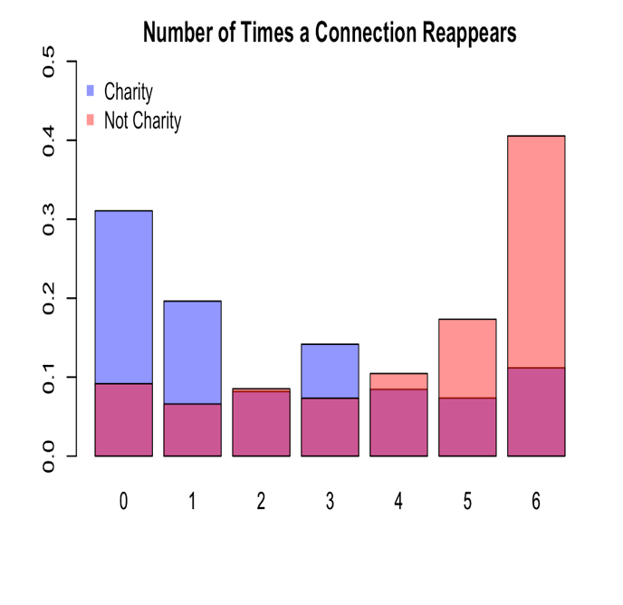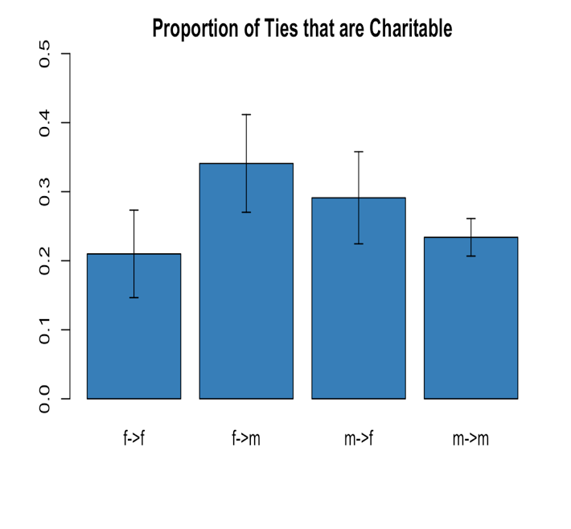

### Change in the Component Distribution

The number of components and the number of isolated students decreased during the course. The number of connected components dropped from 34 to 9 while the number of unconnected students fell from 26 to 4. Meanwhile, the largest component grew from 75 to 94. While this seems like a big drop, this decrease in components and unconnected students is the expected result in the randomly generated graphs produced to test for the increase in assortativity. In fact, the increase in the size of largest connected component is smaller than expected. This suggests that edges were not formed independently of the network structure but that the decrease in components is largely due to the increased number of edges in the network and not some pattern specific to this class.